

CBOE Software Development Process

Revision 3

12/6/2005

Table of Contents
i. Revision History 4
1 Software Development Process Overview 5
2 Overview of Roles 6
3 Development Management Roles 7
3.1 Tier Lead 7
3.2 Tier Manager 8
3.3 Iteration Manager 9
3.4 Developer 9
4 Business and Technical Expertise Roles 11
4.1 Domain Expert 11
4.2 Feature Owner 11
4.3 Technical Manager 12
5 Team Structure 14
5.1 Organizational Structure 14
5.2 New Features Development Teams 15
5.3 SWAT Teams 16
5.4 Resource Allocation and Team Rotation 17
6 Iteration Management Processes 18
6.1 Overview of Iteration Processes 18
6.2 Project Kickoff 20
6.3 Iteration Zero 22
6.4 Iteration Kickoff 24
6.5 Iteration Management 28
6.6 Iteration Close 30
7 Long-term Iteration Management and Planning Processes 34
7.1 Feature Planning 34
7.2 Resource Planning 36
7.3 Long-term Iteration Management 37
7.4 Requirements Engineering, Analysis and Design 39
8 Evaluating and Refining the CBOE Process 42
8.1 Evaluation 42
9 Appendix 43
9.1 Definitions 43
9.2 Typical Developer Calendar 44
9.3 Sample Iteration Kickoff Agenda 45
9.4 Sample Project Feature List 46
9.5 Sample Iteration Task List 47
9.6 Sample Issue / Impediment List 49
9.7 Sample Acceptance Test Case 50
9.8 Sample Prioritized Feature List 51
9.9 Additional CBOE Artifacts 52

Revision History
Date | Version | Description
8/12/04 | 1.0 | Initial release.
4/14/05 | 2.0 | Replaced the role of ScrumMaster with multiple Tier Leads, and removed references to the Scrum process.
12/6/05 | 3.0 | Refined the preplanning phase, including the introduction of Iteration 0 activities and artifacts.

Software Development Process Overview
The CBOE software development process is designed to incorporate the best practices of iterative and agile methodologies into a customized process that fits CBOE’s business climate, corporate culture and constraints. The process is meant to evolve over time; processes and artifacts may be strategically added, changed or removed in order to best serve CBOE objectives.

The major goals of this software development process are to:
- Effectively use time-boxed development to drive the completion of feature development and delivery of features.
- Increase visibility into team progress and facilitate communication between team members in order to effectively share knowledge and mitigate risks.
- Increase accountability and maintain team focus.

Development teams are responsible for maintaining a focus on short-term objectives (iteration objectives). The team commits to a reasonable amount of work within an iteration. One or more assigned leaders (tier leads) are responsible for the completion of assigned tasks by members of their tier, e.g. server, client, infrastructure, as well as the removal of impediments and distractions for the team in order to achieve team goals and meet team deadlines.

Management is responsible for maintaining a focus on long-term goals, setting objectives for development teams and allocating resources to teams to meet those goals and objectives.

Overview of Roles

The roles outlined in this document do not describe titles or positions within an organizational structure, rather the same individual may play multiple roles within the framework of responsibilities and processes. For example, a tier lead may also serve as tier manager; an iteration manager may also serve as a domain expert.

The roles are divided into two types:

- Development management roles, and
- Business and technical expertise roles.

The development management roles describe the roles primarily responsible for managing development teams and producing code. The business and technical roles describe roles primarily responsible for providing expertise and guidance across development teams.

Development Management Roles

Tier Lead

Description
The Tier Lead manages the daily activities of members of a development team (within their tier) during an iteration.

Responsibilities
Keep the development team focused and effective.
Work with the team to identify tasks necessary to complete iteration features
Ensure the completion of features within the iteration.
Communicate risks to the iteration and tier managers as soon as they arise.

Tasks
- Participate in prioritization of features.
- Participate in the identification and estimation of tasks for each feature.
- Identify the subset of standard development artifacts, e.g. IDL Change Document, that must produced during the iteration, and the associated tasks necessary to produce the artifacts.
- Assign tasks to tier members.
- Co-lead (with the other tier leads) a short, focused meeting to communicate daily activities to the entire team. Ensure that each developer succinctly states:
- What she accomplished yesterday,
- What she will work on today, and
- What new tasks are required to complete the feature(s)
- What impediments inhibit the completion of her tasks.
- Manage the iteration task list for their tier.
- Track time remaining and current status of tasks. Calculate (tier) team capacity.
- Escalate project risks to the iteration manager and/or tier managers.
- Manage the iteration impediment list for their tier.
- Either remove impediments or escalate impediments to the iteration manager and/or tier managers.
- Keep the team informed of impediment status.
- Facilitate effective and appropriate communication.
- Ensure team members communicate effectively with domain experts, e.g. to clarify requirements.
- Ensure team members communicate effectively with tier managers, e.g. to contribute / lead design sessions and to review code.
- Assist iteration manager with iteration planning and long-term planning.
- Rapidly respond to immediate high priority business needs, coordinate the reallocation of resources with iteration managers and tier managers, and determine impact to current iteration objectives.
- Provide team member feedback to tier manager(s).

Requisite Skills
Team leadership, team management, and project management.

Tier Manager

Description
The tier manager plans and manages tier-level activities across multiple development teams during an iteration.

Responsibilities
Keep the development teams focused and effective.
Work with the tier leads to identify tasks necessary to complete iteration features
Ensure the completion of features within the iteration.
Communicate risks to the iteration managers as soon as they arise.

Tasks
- Facilitate the prioritization of features and tasks.
- Participate in the identification and estimation of tasks for each feature.
- Identify the subset of standard development artifacts, e.g. IDL Change Document, that must produced during the iteration, and the associated tasks necessary to produce the artifacts.
- Assign tasks to tier members.
- Coordinate activities with tier leads
- Lead the daily meeting when the tier lead is unavailable
- Escalate project risks to the iteration manager.
- Either remove impediments or escalate impediments to the iteration manager.
- Facilitate effective and appropriate communication.
- Ensure team members communicate effectively with domain experts, e.g. to clarify requirements.
- Assist iteration manager with iteration planning and long-term planning.
- Establish realistic expectations and timelines across projects and teams.
- Allocate resources to meet business objectives.
- Rapidly respond to immediate high priority business needs, coordinate the reallocation of resources with iteration managers, and determine impact to current iteration objectives.

Requisite Skills

Business knowledge, team leadership, team management, and project management.

Iteration Manager

Description
The iteration manager plans and manages activities across multiple development teams during an iteration as well as plans iteration and long-term activities beyond current iteration.

Responsibilities
Ensure iteration and project success across development teams.
Manage iteration plan and long-term prioritized feature list.

Tasks
- Manage the iteration plan and long-term prioritized feature list.
- Incorporate new features into list.
- Facilitate the prioritization of features and tasks.
- Establish realistic expectations and timelines across projects and teams.
- Allocate resources to meet business objectives.
- Work with domain experts, feature owners and project stakeholders to plan iterations and establish long-term goals and objectives.
- Update status of features at the close of each iteration.
- Manage project risks, issues and impediments.
- Handle risks escalated by tier leads and managers.
- Remove impediments escalated by the tier leads.
- Work with tier leads and managers to rapidly respond to immediate high priority business needs, coordinate the reallocation of resources, and determine impact to iteration and long-term objectives.
- Back up tier leads as needed.

Requisite Skills
Business knowledge, technical knowledge, team leadership, team management, project management, risk mitigation, and effective communication skills with business staff, development staff, as well as executive level project stakeholders.

Developer

Description
The developers on a team focus on meeting short-term iteration objectives by building high quality code.

Responsibilities
Build high quality software that maximally meets business needs.
Communicate effectively with tier leads and managers to maximize team efficacy.

Tasks
- Write code.
- Work on development tasks allocated during the iteration kickoff.
- Participate in the iteration kickoff meeting.
- Assist tier lead with breaking features down into tasks.
- Assist tier leads with estimating tasks.
- Each developer participates in the daily meeting by succinctly stating:
- What she accomplished yesterday,
- What she will work on today, and
- What new tasks are required to complete the feature(s)
- What impediments inhibit the completion of her tasks.
- Each developer communicates with the tier lead immediately in the event that:
- She will not complete her assigned tasks by the close of the iteration, or
- She will complete her assigned tasks before the close of the iteration.
- Give feedback on team process.

Requisite Skills
Technical knowledge and communication skills.

Business and Technical Expertise Roles

Domain Expert

Description
The domain expert provides expertise in a specific area of business.

Responsibilities
Use knowledge of industry and business practices to clarify and refine requirements.
Work with iteration manager to ensure that iteration plan meets business objectives.
Work with development teams to ensure that functionality meets business needs.

Tasks
- Coordinate with domain experts outside of development (such as trading operations, system planning, system committee and membership) to understand and articulate business objectives.
- Represent business priorities during iteration planning.
- Clarify and refine feature definitions, requirements documents and acceptance tests. Ensure these documents properly articulate business needs.
- Work with iteration managers to prioritize features and development tasks based on business expertise.
- Act as a proxy for the actual end user during development.
- Participate in iteration kickoff meetings to represent business requirements.
- Answer development team questions about business functionality.
- Review features to ensure functionality meets business needs and acceptance criteria.

Requisite Skills
Extensive business knowledge and effective communication skills with business, as well as development staff.

Feature Owner

Description
The feature owner serves as a domain expert with additional management responsibility and accountability for features articulated in a chartered system project, interim, or maintenance project.

Responsibilities
In addition to domain expert responsibilities:
Represent chartered project, interim, or maintenance project objectives.

Tasks
In addition to domain expert tasks:
- Represent chartered project goals during planning and development.
- Work with project stakeholders to establish and articulate project objectives.
- Work with iteration manager to ensure iteration and long-term plans meet project objectives.
- Facilitate requirements gathering, documentation and information dissemination.
- Resolve scope and requirements issues.

Requisite Skills
In addition to domain expert skills:
Business leadership, project management and effective communication with project stakeholders.

Technical Manager

Description
The technical manager provides technical expertise and leadership in a specific architectural tier (e.g. server, client), or software layer (e.g. middleware), and guides development staff in the design, implementation and support of functionality within that tier.

Responsibilities
Within a specific architectural tier:
Ensure architectural integrity, reliability and quality.
Provide technical design and implementation expertise in iteration and long-term planning activities as well as development iterations.
Ensure staff career development and training.

Tasks
- Ensure tier quality.
- Provide executive level status.
- Assist in resolution of production issues.
- Plan performance and reliability improvements.
- Provide technical direction across teams and projects.
- Define technical requirements.
- Participate in planning and prioritizing feature development.
- Provide technical direction to development teams. Participate in iteration kickoff meetings and in design sessions. Perform design reviews.
- Develop staff technical skills.
- Manage staff development and training.
- Perform iteration and annual reviews.

Requisite Skills
Extensive technical knowledge, team leadership, team management, and effective communication skills with business staff, development staff, as well as executive level project stakeholders.

Team Structure

Organizational Structure
The iteration manager, tier managers, and tier leads work closely together to manage team activities. The iteration manager focuses on planning and coordinating with stakeholders and the tier managers and leads focus on maximizing development team capabilities and the production of code. Feature owners, domain experts and technical managers provide expertise to iteration managers, tier managers, tier leads and development teams.

Roles and team membership remain relatively stable and predictable during an iteration, but may be expected to change based on resource planning and the support schedule.

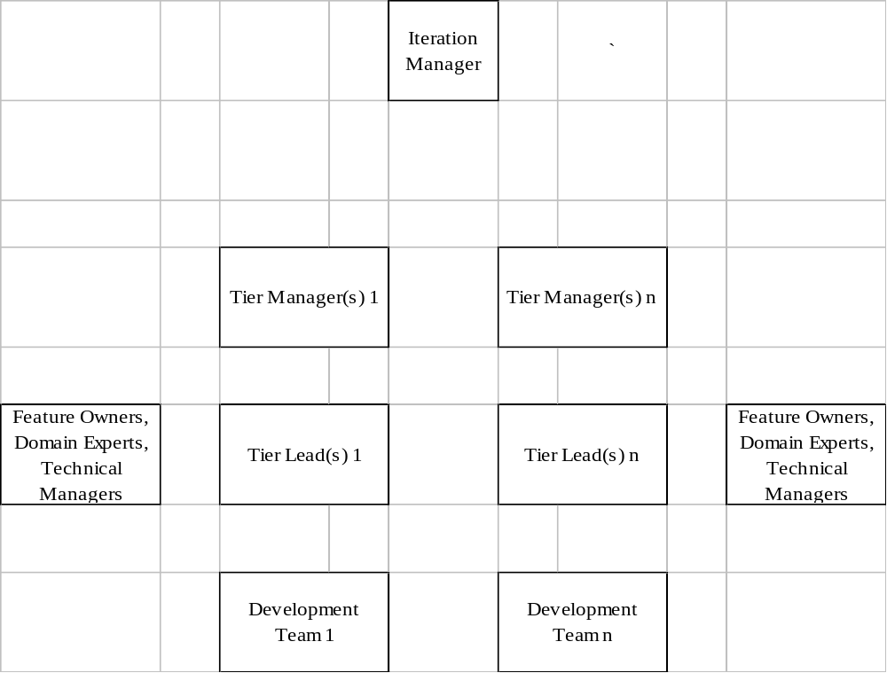

New Features Development Teams
New features development teams implement new functionality as articulated in the prioritized feature list. New features are likely to have originated in a project charter or as an independent enhancement request.

Team Structure
New features iteration managers supervise several tier managers. Each tier manager supervises several development teams. Each development team has one or more tier leads that manage daily team activities. Tier leads report to the tier manager.

Development teams are partitioned along functional (tier) lines. Features are grouped together sensibly and teams allocated according to these groups of features (which may cross projects). Team membership is based on skill set in order to ensure that the relevant tiers are properly represented within a given team.

Feature owners, domain experts and technical managers represent their areas of expertise to the new features development teams at all levels: iteration manager, tier manager(s), tier lead(s) and developers.

Team Responsibilities
New features development teams are responsible solely for implementing a group of features from the prioritized feature list. All other activities (those outside tasks related to the development of new features) are considered impediments to team progress.

Development teams are responsible for the installation and configuration of their assigned development environment(s).

When a member of a new features development team is scheduled to serve on primary or secondary support, she is considered unavailable to the new features team and a member of the SWAT team responsible for support.

Team Process
Since these teams focus solely on the development of new features, team activities are relatively stable. The tier manager(s) and tier lead(s) are able to plan team activities.

SWAT Teams
SWAT teams are responsible for, in essence, everything but implementing new features.

Team Structure
SWAT iteration managers supervise one or more tier managers. Tier managers supervise one or more SWAT teams. Each team has one or more tier leads that report to the tier manager to manage daily team activities. SWAT teams may be organized by tier.

SWAT teams are partitioned according to individual team responsibilities. Feature owners, domain experts and technical managers represent their areas of expertise to the SWAT teams at all levels: iteration manager, tier managers, tier leads, and developers.

During an iteration, SWAT teams may be temporarily partitioned into sub-teams that are responsible for one or more areas, e.g. rollout, defect removal, etc. Team members may be assigned to one or more sub-teams during the iteration.

Team Responsibilities
- Production system support
  - System rollout
  - Environment configuration
  - Defect removal
- Test system support (ATG, API, and Performance)
  - System rollout
  - Environment configuration
  - Defect removal
  - Answering questions on usage and functionality
- Development support (as requested)
  - System rollout
  - Environment configuration
- Minor enhancements
- Tool building and automation
  - Rollout tools
  - Automated testing
  - Environment support tools
- Completion and submission of documentation (to IRB)

Team Process
The activities of SWAT teams change regularly and rapidly in response to immediate support of CBOE systems. The tier manager works very closely with tier leads to maintain and prioritize a comprehensive list of activities. These activities may change on a daily (if not hourly) basis. Partitioning of the team into sub-teams may be required to ensure progress in one or more areas, e.g. rollout testing, is not severely impeded by tasks in another area, e.g. production support.

All activities of the SWAT teams are tracked and prioritized to ensure that the highest priority items are addressed first and so that areas that would benefit from automation, process improvement or system changes are be identified and addressed.

Resource Allocation and Team Rotation
Iteration managers create and maintain the plan for resource allocation in order to best meet CBOE objectives. The primary and secondary support schedule is planned in advance of resource allocation to other development teams and takes first priority. Resources are allocated and team membership changes to achieve several goals:
- Ensure adequate production support
  - Resources are allocated first to ensure the demands of providing production support are met.
  - While serving on support, team members are temporarily relieved of all team duties including development tasks and daily meeting attendance. Tier leads take into account support responsibilities in the allocation of development tasks.
- Build highest priority functionality (as outlined in the prioritized feature list)
  - Teams may be created or change size from iteration to iteration.
- Effectively put new functionality into production
  - Some staff involved in the development of the functionality move to the SWAT team charged with putting that functionality into production.
- Maintain team stability
  - A core of team members remains working together.
- Grow staff
  - Team members may be rotated to broaden exposure to CBOE architecture, systems and IT activities.

Iteration Management Processes
Goal: Mitigate risk and maximize team efficacy through frequent communication and short-term focus.

Iterations are short, time-boxed intervals of development. During an iteration, development teams focus solely on meeting the goals of that particular iteration. Teams meet daily to communicate about the day’s activities, progress and impediments to progress. The team handles or escalates issues, risks and impediments immediately.

At CBOE, iterations serve as a development management time-boxed interval and are 4 weeks in duration. Iterations serve as a time-box for setting and managing user expectations as well as system rollouts.

The goal of the iteration is the completion of all features selected for the iteration. While the development of production quality artifacts (e.g. code, documentation) is highly encouraged, the complexity and/or nature of the feature may require more than a single iteration to complete the feature. In this case, the feature may be sub-divided by the team into parts that can each be scheduled and completed in a single iteration. The breakdown of a feature may be by scenario, i.e. all phases completed for a subset of feature scenarios, or along phase lines, i.e. analysis, design, coding, and testing.

At CBOE, projects are the primary means of planning, organizing, and delivering features that satisfy a particular business need. Rarely can a single feature be developed and delivered that provides a single complete business function. In the majority of cases, the number of features defined within the scope of a project require more than a single iteration to complete. As such, additional processes and procedures have been defined to manage the features associated with a multi-iteration project.

Overview of Iteration Processes

Project Kickoff
Goal: Set the focus for a multi-iteration project.
Run brief, effective all-hands meeting resulting in an understanding of the project scope, the selection of the preplanning team, i.e. Iteration Zero Team, and the selection of a timebox for delivery of the preplanning artifacts.

Iteration Zero
Goal: Define the architecture for the project.
Goal: Define the set of features to be developed over the course of the project.
Goal: Define an iteration plan, including the estimates for each feature, the project length (i.e. number of iterations), and the project schedule (i.e. when each feature will be developed).
Run preplanning meetings with the preplanning team, and other stakeholders, in order to develop the preplanning artifacts.

Iteration Kickoff
Goal: Set the focus for 4-week iteration.
Run brief, effective team meeting resulting in a team task list (with estimates) for the iteration.

Iteration Management
Goal: Maintain the iteration focus.
Goal: Remove obstacles to team progress.
Goal: Assess progress and risk daily.
Run daily meetings and manage the iteration task list.

Iteration Close
Goal: Review iteration process and progress.
Goal: Measure team capacity.
Determine completed functionality.
Make process improvements for next iteration.
Calculate team capacity.

Project Kickoff
Each project begins with a short, all-hands meeting focusing the team on a new project’s goals. The meeting should be scheduled in advance to ensure that all interested staff can attend.

Goals
The goals of the project kickoff meeting are to:
- Gain a common understanding of the business goals to be achieved by the project,
- Briefly review the project charter to determine if it accurately reflects the current vision for the project,
- Identify the length of time required for preplanning activities, thus identifying the target date for the iteration 1 kickoff,
- Identify the members of the preplanning team, selected by their respective managers.

Participants

Iteration Managers, Tier Managers and Tier Leads
The iteration managers, tier managers and tier leads serve as the kickoff meeting facilitators and are responsible for keeping the kickoff meeting focused and effective. Subsequent meetings, such as design, estimation, and planning sessions, may be scheduled during the project kickoff.

Domain Experts
Domain experts represent business interests and expertise in the kickoff meeting. They present an overview of business features and prepare supporting requirements documentation for the meeting. They answer questions and clarify requirements as needed by the development team to break down and estimate features.

If a domain expert is unable to attend the project kickoff meeting, the tier leads ensure that her interests and expertise are represented during the meeting.

Technical Managers
Technical managers present an overview of technical features and prepare supporting requirements documentation for the meeting. They answer questions and clarify technical requirements as needed by the development team to break down and estimate features.

Developers
The primary responsibility of developers during the project kickoff meeting is to gain an overall understanding of the business goals of the project.

Preparation
New business and technical functionality has been preliminarily identified for the project in the form of a project charter.

Resources have been tentatively planned for the project. If a staff member may be involved in the project at some point, it’s probably worth their time to attend the brief project kickoff meeting.

Relevant documentation has been organized and prepared. Packets have been created for each meeting participant. At a minimum, the project charter should be distributed to each attendee.

A room sufficiently sized to have all meeting participants present and able to hear / participate has been reserved.

Artifacts

Requirements Artifacts
The requirements artifacts are organized by feature.

Business Requirements Documents
Requirements documents outline the details of the features slated for the project.

Technical Requirements Documents
Technical documentation outlines the details of the technical features slated for the project.

Upfront Design Documents
Upfront design documentation outlines high level analysis and design that occur before the project begins, i.e. during the charter process.

Acceptance Test Cases
Acceptance tests, when available, serve as the primary requirement artifact during a project. When all the acceptance test cases pass for a feature, the development is complete and the functionality is ready for review and testing.
(See the Appendix for a sample acceptance test case.)

Process

Part 1 – Project Goals and Feature Overview
The first part of the meeting is devoted to a discussion of the business goals of the project, and a brief overview of the functional requirements of the project.

This first part of the meeting is kept tightly focused by the tier managers and leads. All details of a feature need not be presented. Issues and impediments that arise during the meeting are tabled until after the meeting.

Part 2 – Determine Iteration Zero Length
The second part of the meeting is devoted to determining the length of the preplanning activities. Projects that are well defined, with few unknowns, may require a very short preplanning period. Larger, or more complex projects may require an extended preplanning period. However, to avoid “analysis paralysis”, the preplanning period should not exceed 4 weeks.

Part 3 – Determine Iteration Zero Team
The third part of the meeting is devoted to selecting the preplanning team. This is led by the managers to ensure that:
- Appropriate team members from each area are assigned to the team,
- Activities are being worked on by a relatively small group of people.

Results
Meeting participants understand the scope of work for the project. Preplanning activities are planned. Subsequent meetings may be scheduled.

Iteration Zero
Each project begins with a brief preplanning phase known as Iteration Zero.

Goals
The goals of Iteration Zero are to:
- Learn more about the project requirements.
- Break down the project into features, sized so that can be developed within a single iteration, if possible. Features should be cataloged in the Project Feature List.
- Provide estimates for each feature.
- Define the architecture/high-level design that will fulfill the project features, including non-functional requirements.
- Define an iteration plan that specifies the estimated number of iterations that will be required to complete the project (based on the feature estimates and available resources), and assign the features to an iteration.

Participants

Tier Managers and Tier Leads
The tier managers and tier leads serve as the Iteration Zero facilitators and are responsible for keeping the planning period focused and effective.

Domain Experts
Domain experts represent business interests and expertise. They answer questions and clarify requirements as needed by the development team.

Technical Managers
Technical managers answer questions and clarify technical requirements as needed by the development team to break down and estimate features.

Developers (Preplanning Team)
The primary responsibility of developers during Iteration Zero is to define the high-level architecture/design of the system(s), and produce the project feature list, which includes the iteration plan.

Preparation
The project kickoff meeting completed and the Iteration Zero Team selected.

Artifacts

Requirements Artifacts
The requirements artifacts include any documentation that may be useful in determining the requirements, scope, or technical aspects of the system.

Business Requirements Documents
Requirements documents outline the details of the project features, e.g. project charter.

Technical Requirements Documents
Technical documentation outlines the details of the project’s technical.

Process
The preplanning team conducts a series of meetings, design sessions, and/or workshops attended by the team, and others as needed, e.g. tier managers, domain experts.

Results
The preplanning team has a firm understanding of the scope of work for the project. The first iteration kickoff meeting can be scheduled. The preplanning team produced the following artifacts:

Project (Iteration) Feature List and Iteration Plan
The tier leads generate a single project feature list and iteration plan. The list captures for each feature: the feature owner, the initial estimate, and the assigned iteration.
(See the Appendix for a sample project feature list.)

Design Documents
The preplanning team generates one or more design documents, models, or diagrams depicting the high-level design for the system. Various groups may develop standards for documentation that are applicable to their area of specialty.

Iteration Kickoff
Each iteration begins with an all team meeting rapidly focusing the team on a new iteration’s activities.

Goals
The goals of the iteration kickoff meeting are to:
- Gain a common understanding of all functionality to be worked on during the iteration, including feedback from the previous iteration,
- Break functionality down into tasks, providing just enough information to estimate tasks and allocate work, and
- Ensure that a reasonable amount of work is slated for the iteration and that the highest priority features are allocated to the iteration.

Participants

Tier Managers and Leads
The tier managers and leads serve as the kickoff meeting facilitators and are responsible for keeping the kickoff meeting focused and effective. Discussion is limited to the functionality that will be worked on during the iteration and kept at a level just detailed enough to break down features into tasks and to estimate those tasks. The kickoff meeting is not an appropriate venue for design discussions; the meeting results in an iteration task list outlining what to do during the iteration and how long it will take, not how to accomplish each task. Important issues to be handled outside the kickoff meeting are captured, but not discussed during the meeting. Subsequent meetings, such as design sessions, may be scheduled during the iteration kickoff.

Domain Experts
Domain experts represent business interests and expertise in the kickoff meeting. They present an overview of business features and prepare supporting requirements documentation for the meeting. They answer questions and clarify requirements as needed by the development team to break down and estimate tasks.

If a domain expert is unable to attend the iteration kickoff meeting, the tier leads ensure that her interests and expertise are represented during the meeting.

Technical Managers
Technical managers present an overview of technical features and prepare supporting requirements documentation for the meeting. They answer questions and clarify technical requirements as needed by the development team to break down and estimate tasks.

Developers
The primary responsibility of developers during the iteration kickoff meeting is to assist the tier leads with the break down of features into development tasks, and the estimation of those tasks.

Feature Owners and Iteration Manager
The feature owners and iteration manager determine what features will be worked on in the iteration. After the functionality has been broken down into estimated tasks, these stakeholders fill the iteration task list up to the team capacity, based on business priorities.

If a feature owner or iteration manager is unable to attend the iteration kickoff meeting, the tier leads ensure that her interests and expertise are represented during the meeting.

Preparation
The previous iteration has closed and incomplete features have been identified. For the first iteration, the preplanning process has been completed.

New business and technical functionality has been preliminarily identified for the iteration.

Resources have been planned for the iteration – the development team list for the iteration has been finalized and the team capacity (the amount of work the team is able to complete during an iteration) has been calculated.

Meeting documentation has been organized and prepared. Packets have been created for each meeting participant.

A room sufficiently sized to have all meeting participants present and able to hear / participate has been reserved.

Artifacts

Project (Iteration) Feature List and Iteration Plan

The list serves as a starting point for feature selection, and initial estimates.

The Iteration Task List

Open Items from the Previous Iteration Task List
The previous iteration task list is updated with final statuses for each task at the close of the previous iteration. Features and tasks with remaining work carrying over from the previous iteration are compiled and incorporated into the new iteration task list.

New Features
New features slated for the iteration are selected from the prioritized feature list and incorporated into the new iteration task list.

Requirements Artifacts
The requirements artifacts are organized by feature and compiled in the order of features on the iteration kickoff meeting agenda and the new iteration task list.

Business Requirements Documents
Requirements documents outline the details of the features slated for the iteration that assist in task breakdown and estimation.

Technical Requirements Documents
Technical documentation outlines the details of the technical features slated for the iteration that assist in task breakdown and estimation.

Upfront Design Documents
Upfront design documentation outlines high level analysis and design that occur before the iteration begins.

Acceptance Test Cases
Acceptance tests, when available, serve as the primary requirement artifact during an iteration. When all the acceptance test cases pass for a feature, the development is complete and the functionality is ready for review and testing.
(See the Appendix for a sample acceptance test case.)

Team List and Calendar
List all team members (including feature owners, domain experts, tier managers, technical managers, in addition to development team members) and days when team members are unable to participate in the iteration (due to vacations, the support schedule, etc.).

Sample Agenda
An agenda is included in the documentation packet as the first page. An agenda for the first iteration in a multi-iteration development effort, or for a particularly unique iteration, may have additional agenda items that serve as a team introduction to the overall project goal.
(See the Appendix for a sample iteration kickoff agenda.)

Process

Part 1 – Task Breakdown and Estimation
The first part of the meeting is devoted to breaking down features into development tasks and estimating those tasks. For each feature, an expert describes the functionality with just enough detail for the team to break down and estimate tasks. An expert could be a domain expert for new business functionality, a technical manager for new technical functionality or the developer who worked on the feature for tasks remaining from the previous iteration. The team then discusses the development tasks required to complete that feature. These tasks may include documentation required to rollout the feature, such as an implementation plan. The tier leads capture tasks. After the tasks for a feature are determined, tier leads, assisted by the tier developers, estimate each task. The estimates for the feature are then totaled.

The tier managers and leads keep this first part of the meeting tightly focused. All details of a feature need not be presented, nor is task breakdown expected to constitute design. Rather, just enough information is presented to inform the entire team about what features will be worked on in order to create an estimated task list. Issues and impediments that arise during the meeting are tabled until after the meeting.

Part 2 – Feature Selection
The second part of the meeting is devoted to selecting the features and tasks for the iteration. Equipped with estimates for each feature (and tasks for the feature), the feature owners and iteration manager choose which features will be worked on during the iteration. The iteration plan serves as an initial starting point. The team capacity has already been determined for the iteration. Stakeholders choose functionality up to the team capacity. Generally, there will be enough functionality from which to choose. If not, additional functionality is selected during the meeting or shortly thereafter from the prioritized feature list and added to the iteration.

Part 3 – Task Allocation
The third part of the meeting is devoted to allocating the iteration’s tasks to the development team. This is led by the tier leads to ensure that:
- Appropriate team members are assigned to tasks,
- Features are being worked on by a relatively small group of people, and
- Team members are not spread too broadly across features.

Results
Meeting participants understand the scope of work for the iteration. Developers have been assigned all the tasks for which they will be responsible during the iteration, and are ready to begin designing and coding their features. Subsequent meetings may be scheduled.

Project (Iteration) Feature List and Iteration Plan
The list is updated to identify the features selected for the iteration, reflect new or modified estimates, and feature owner(s).

Iteration Task List
The tier leads generate a single iteration task list from the meeting results. The task list captures for each feature: the development tasks, estimates, and allocated developer.
(See the Appendix for a sample iteration task list.)

Issue / Impediment List
The tier leads generate a list of issues and impediments that arise during the meeting, and incorporate this list into the impediment list for the iteration.
(See the Appendix for a sample issue / impediment list.)

Iteration Management
An iteration is a short, time-boxed period (4 weeks) during which development occurs. Iteration length is fixed; work not completed during the iteration rolls into a later iteration. Iterations are never extended, but are managed to this fixed time-box.

Goals
The goals of iteration management are to:
- Keep the development team focused on tasks,
- Ensure effective communication (including formal or informal design sessions and code reviews),
- Escalate issues, impediments and risks to the iteration, and
- Use time-boxed development to measure how much work the team is able to do and use those metrics to forecast long-term schedules.

Participants

Tier Managers and Leads
The tier managers and leads run a daily development team meeting (the daily meeting), manage the iteration task list, and manage the impediment list in order to keep the development team focused and effective. The tier leads escalate issues, impediments and risks to the iteration and tier managers when appropriate.

Technical Manager

The technical manager provides technical expertise and leadership in a specific architectural tier to the team, and guides development staff in the design, implementation and support of functionality within that tier.

Developer
The primary responsibility of a developer during the iteration is to complete the development tasks allocated to her during the iteration kickoff meeting and to alert their tier lead if her development tasks are at risk, or if her development tasks will be completed early.

Iteration Manager
While the tier leads focus on the current iteration, the iteration manager focuses on the big picture: the prioritized feature list, project timelines, resource allocation and risk mitigation. Issues, impediments, and risks that cannot be resolved during the iteration or by the tier leads are escalated to the iteration manager. The iteration manager may perform the duties of a tier lead in the event that a tier lead is unavailable.

Preparation
The iteration kickoff process completed and an initial iteration task list created.

Artifacts

Iteration Task List
The iteration task list contains for each feature: the development tasks, initial estimate, developer, task status and remaining estimate for each day of the iteration.
(See the Appendix for a sample iteration task list.)

Impediment List
The impediment list contains a description for each impediment, impediment status and the person responsible for resolving the issue.
(See the Appendix for a sample issue / impediment list.)

Process

Run Daily Meetings
The daily meeting is a short (~15 minute) meeting held at the same time and in the same place. Its purpose is for each developer to communicate succinctly to the team:
- What she accomplished yesterday,
- What she will work on today (including tasks outside the iteration task list),
- What impediments inhibit the completion of her tasks, and
- What new tasks have been identified for each feature

In addition, the tier leads report the status of each open impediment to the team.

The daily meeting is neither a design meeting nor an issue resolution meeting. Such meetings may be scheduled during or immediately after the daily meeting.

Ensure Effective Communication
In addition to ensuring effective team communication during the daily meetings, the tier leads are responsible for ensuring that formal or informal design sessions and code reviews occur with the appropriate resources involved.

Manage Iteration Task List
The tier leads maintain the iteration task list to manage development tasks, mitigate risks and escalate issues. The document is used only during the iteration; at the close of an iteration, feature status is rolled back into the prioritized feature list and incomplete features / tasks are rolled into the next iteration task list. Because iteration are so short, the task list is not used to track dependencies, nor is it used to schedule each task.

Manage Impediment List
The tier leads capture impediments, attempt resolution, and escalate impediments as necessary. The tier leads keep the development team apprised of the status of impediments.

Iteration Close
At the end of an iteration, a final status is determined for each task and each feature worked on during the iteration. Domain experts and feature owners may review completed features. Feedback in the form of enhancements, refinements or improvements to the functionality is incorporated into subsequent iteration through the iteration manager and the prioritized feature list. The close of an iteration also provides an opportunity to collect feedback from the team on the iteration and to incorporate process improvements into the next iteration.

Goals
The goals of closing an iteration are to:
- Determine final status for each feature and task in the iteration task list,
- Review completed functionality to ensure business needs are met,
- Collect feedback on the iteration process, and
- Calculate team capacity.

Participants

Tier Leads
At iteration close, the tier leads update the iteration task list with final statuses, coordinates the review of completed functionality by appropriate domain experts or feature owners, reviews the iteration process, calculates team capacity and creates the next iteration’s impediment list.

Tier Managers

At iteration close, the tier manager coordinates with the tier leads, iteration manager, domain experts, and feature owners to update the prioritized feature list with the results of the iteration. The tier manager reviews the current iteration and the iteration process with the tier leads.

Developers
At iteration close, the developers determine/report the final status of the iteration’s tasks and features (preferably by executing acceptance test cases successfully), and demonstrate completed features. They also give feedback on the iteration process.

Domain Experts or Feature owners
At iteration close, domain experts or feature owners review completed features.

Technical Managers
At iteration close, the technical manager reviews the completed non-functional requirements and features.

Iteration Manager
At iteration close, the iteration manager coordinates with the tier leads, tier managers, domain experts, technical managers, and feature owners to update the prioritized feature list with the results of the iteration. The iteration manager reviews the current iteration and the iteration process with the tier leads and managers.

Artifacts

Iteration Task List
The iteration task list used to manage the current iteration is updated with final statuses for each task and feature. The iteration task list is archived at iteration close. The next iteration will use a new task list.
(See the Appendix for a sample iteration task list.)

Issue / Impediment List
The impediment list used to manage impediments during the current iteration is reviewed. Remaining impediments will be rolled into a new impediment list for the next iteration.
(See the Appendix for a sample issue / impediment list.)

Prioritized Feature List
The prioritized feature list is used to manage iteration goals as well as goals extending beyond the current iteration. At iteration close, this big picture plan is updated with the results from the current iteration.
(See the Appendix for a sample prioritized feature list.)

Process

Determine Final Status of Iteration Tasks
At the end of the iteration, the developers give a final status on each of their development tasks and their tier lead updates tasks on the iteration task list accordingly.

Determine Final Status of Iteration Features
When all the tasks for a feature are completed (including documentation tasks such as writing an implementation plan), the status of the feature is evaluated as objectively as possible. Ideally, the status of a feature would become “Complete” when all the acceptance tests for the feature pass. In the absence of objective criteria like acceptance tests, it becomes more important that a feature deemed “Complete” by a developer be evaluated by a second party – preferably a domain expert or feature owner. The tier lead updates features on the iteration task list accordingly.

Review Completed Features
When a feature is completed, a domain expert or feature owner assesses whether the feature maximally meets business needs. This may be accomplished in a formal demonstration of all completed features at the end of an iteration or on a more informal basis as features are completed during the iteration.

If a feature does not completely meet business needs, the feedback given by the domain expert may result in:
- The feature being changed to maximally meet business needs, acceptance criteria being modified accordingly, the feature being re-estimated and the modified feature being slated for a future iteration, or
- A new feature being added to the prioritized feature list to describe additional requirements to maximally meet business needs.

Domain experts may provide feedback that affects features outside the iteration that may result in:
- Other features being changed in light of the reviewed features (which may require re-estimation and modification of acceptance criteria), or
- Additional features being added to the prioritized feature list and / or a new project charter.

Update the Prioritized Feature List
The iteration manager updates the prioritized feature list with the final statuses of features from the iteration task list. If a feature is complete, the feature is marked “Complete”. If a feature is not complete, it rolls into a future iteration based on current priorities (which may or may not be the next iteration), and the feature is noted to have tasks remaining from the current iteration (for reference in the kickoff of subsequent iteration).

The iteration manager updates the prioritized feature list with the feedback from domain experts and feature owners.

Collect Feedback on Iteration Process
The iteration manager and the tier leads collect feedback on the iteration from the development team. This may be accomplished in a formal team meeting or individual team members may submit suggestions to the tier leads or iteration manager. The focus of the feedback is on evolving a process that maximizes team efficacy and CBOE goals.

The iteration manager and the tier leads review the impediment list, development practices, project management practices, the iteration process, and the team feedback in order to evolve the team process in subsequent iterations. The tier leads roll remaining impediments into the impediment list for the next iteration.

Calculate Team Capacity
After obtaining final statuses for all the tasks worked on during the iteration, the tier leads calculate team capacity for the iteration. The team capacity is the sum of the iteration kickoff estimates of all completed tasks. Partially completed tasks do not enter into this sum. The tier leads, tier managers, and iteration manager work together to estimate team capacity for the next iteration based on the current team capacity, staffing changes, resource availability and any other known factors that may impact team capacity during the upcoming iteration.

It should be noted that calculated team capacity is usually significantly less (often under 50%) than total resource availability. The purpose of calculating team capacity is to use objective metrics in order to plan team activities and lay out the prioritized feature list into iterations. Some teams use an arbitrary unit of estimation in order to avoid confusion between estimated effort and actual availability.

Results
The close of the iteration provides an opportunity to assess progress, review functionality, review the team process and calculate team capacity.

Code for completed features is ready to be merged into the appropriate code base at the discretion of the iteration manager as part of the iteration management process.

Iteration Task List
The current iteration task list contains final statuses and is archived.

Impediment List
Impediments that remain from the current iteration are rolled into the impediment list for the next iteration. The current impediment list has been reviewed and is archived.

Prioritized Feature List
The prioritized feature list is updated with the results of the iteration, and with feedback given by domain experts and feature owners.

Long-term Iteration Management and Planning Processes

Feature Planning

Goals
The goals of agile feature planning are to:
- Easily and continually incorporate new project charters and new requirements into the prioritized feature list, and
- Efficiently meet the goals of each particular planning stage by breaking down and estimating functionality to the appropriate level.

Participants

Systems Planner
Drafts project charter.

Domain Expert, Feature Owner, Technical Manager, Tier Manager, and Tier Lead
Breaks project charter into features.

Tier Lead, and Developer
Estimates project charter and features.

Iteration Manager
Manages prioritized feature list.
Coordinates prioritization of features with project stakeholders.

Artifacts

Project Charter
A project charter is a document drafted by systems planners to initially articulate business functionality requested by the CBOE user community.

Prioritized Feature List
The prioritized feature list is a document used to manage iteration goals as well as long-term goals extending beyond the current iteration. At iteration close, this big picture plan is updated with the results from the current iteration.
(See the Appendix for a sample prioritized feature list.)

Process

Draft Project Charter
Systems planners work with users and stakeholders to articulate business needs and outline functionality and features.

Estimate Project Charter
Developers, tier leads, or tier managers provide an initial estimate of a project charter.

Reject / Approve Project Charter
After a charter has been drafted and estimated, stakeholders determine whether to approve or reject the charter.

Break Charter into Features
Once a charter is approved, the functionality outlined in the project charter is broken down into features.

Identify Other New Features
Features may arise outside of a project charter, but follow a similar process in order to be added to the prioritized feature list. For example, ideas for additional or alternate functionality may arise during the feedback process. The iteration manager ensures that this functionality is articulated, initially estimated and evaluated by the appropriate business or IT staff, and subsequently incorporated into the prioritized feature list.

Identify Changed Features
Over the life of a project, the functionality outlined in features may change. This often happens as part of the feedback process during development. When a feature changes enough, it requires a new estimate.

Estimate Features
Tier leads, tier managers, and developers estimate features. The goal of this level of estimation is for planning and prioritization purposes. They do not break features down into tasks until the iteration kickoff meeting.

Prioritize Features
Once functionality has been broken down into features and estimated, the iteration manager works with the appropriate business stakeholders to prioritize the features. Though features may be initially prioritized within the context of a project charter, the ultimate goal is to prioritize new features within the context of the entire prioritized feature list.

Update the Prioritized Feature List
After new features have been prioritized, the iteration manager updates the prioritized feature list accordingly.

Resource Planning

Goals
The goals of resource planning are to:
- Effectively allocate resources to iterations to maximally meet business priorities, and
- Use metrics gathered during development to forecast project timelines and lay out features into iterations.

Participants

Iteration Manager
Manage prioritized feature list.
Allocate resources to iterations.
Lay features out into iteration based on team capacity and resource allocation.

Artifacts

Prioritized Feature List
The prioritized feature list is used to manage iteration goals as well as goals extending beyond the current iteration. At iteration close, this big picture plan is updated with the results from the current iteration.
(See the Appendix for a sample prioritized feature list.)

Iteration Resource Schedule
The resource schedule outlines team composition by iteration for all teams. It includes resource availability (vacation and support schedules) and team capacity.

Process

Determine Estimated Team Capacity for Future Iterations
The iteration manager uses metrics provided by tier leads regarding past team capacity and planned changes to resource allocation in order to estimate team capacity for future iteration. If there are no planned staffing changes, it is safe to assume that the previous iteration capacity provides an accurate estimate of future iteration capacity. When team size decreases, the impact is felt immediately. When team size increases, it may take a few iterations for the new team member to get up to speed.

Resources are allocated first to production support and then to new functionality teams in order to allow new functionality teams concentrate on the features in the prioritized feature list and to ensure that sufficient coverage is provided to maintain current systems.

Lay Out into Iterations
The iteration manager identifies features to be completed during an iteration based on resource allocation, feature priority, and estimated team capacity.

One technique to aid in the prioritization of the feature list is to use index cards. The details of each feature – its description, estimate, etc – are printed on an index cards. The index cards are laid out on a table into piles representing iteration. New features are then folded into the plan based on their priority and the functionality shifts to different iterations based on the estimated team capacity for each iteration.

Update the Prioritized Feature List
After new features have been laid out into iteration, the iteration manager updates the prioritized feature list accordingly.

Long-term Iteration Management

Goals
The goals of agile project management are to:
- Provide internal IT management support to iteration teams, including:
  - Ensure iteration teams work on the highest priority functionality to maximally meet business needs, and
  - Measure team progress and mitigate risks to help iteration teams perform at maximal efficiency and efficacy.
- Provide iteration level management and reporting, including:
  - Involve domain experts in iteration kickoff and iteration close activities and planning, and
  - Provide project progress reporting for management.

Participants

Tier Managers and Leads
Measure team capacity.
Report on team impediments.
Report on iteration progress.

Technical Managers
Provide technical direction
Define technical requirements
Identify non-functional features for incorporation into the feature list
Identify risks
Assist in prioritizing feature development

Domain Experts, and Feature Owners
Participate in iteration kickoff.
Provide feedback at the end of an iteration.

Iteration Manager
Manage prioritized feature list.
Incorporate feedback into planning process.
Plan iteration kickoff and iteration close activities.
Coordinate project reporting to stakeholders.
Coordinate merging of code bases.

Artifacts

Prioritized Feature List
The prioritized feature list is used to manage iteration goals as well as goals extending beyond the current iteration. At iteration close, this big picture plan is updated with the results from the current iteration.
(See the Appendix for a sample prioritized feature list.)

Iteration Task List
The iteration task list contains for each feature: the development tasks, initial estimate, developer, task status and remaining estimate for each day of the iteration.
(See the Appendix for a sample iteration task list.)

Issue / Impediment List
The impediment list contains a description for each impediment, impediment status and the person responsible for resolving the issue.
(See the Appendix for a sample issue / impediment list.)

Project Reports
Stakeholders and senior management may require specific project reports in order to track project progress.

Iteration Processes

Provide Initial Iteration Features
At the beginning of an iteration, the iteration manager pulls the iteration’s features from the prioritized feature list for each iteration team.

Incorporate Iteration Results into Prioritized Feature List
At the end of an iteration, the tier leads provides the iteration manager with the results from the current iteration including:
- Completed features,
- Incomplete features and their remaining estimates, and
- Team capacity for the iteration (= the sum of the estimates from the prioritized feature list of completed features).

Review Impediments
The iteration manager meets with the tier managers and leads to review the impediments during the iteration and remaining impediments.

Plan Iteration Kickoff
At the beginning of each iteration, the iteration manager coordinates the involvement of domain experts, project stakeholders, and technical managers in the initiation of a new iteration including upfront high-level analysis and design. The iteration manager schedules an iteration kickoff meeting during which domain experts, project stakeholders, and technical managers provide iteration teams with an overview of the iteration, project goals and upfront design. This meeting may involve multiple teams in order to establish the proposed approach and gain agreement across teams. When necessary, the iteration manager may delegate this responsibility to the tier manager(s) or lead(s).

Plan Iteration Close
At the end of an iteration, the iteration manager coordinates the involvement of domain experts, project stakeholders, and technical managers in the review of iteration functionality and the collection of feedback. When necessary, the iteration manager may delegate this responsibility to the tier manager(s) or lead(s).

The iteration and tier managers works with IT staff and project stakeholders to plan the merging code bases, quality assurance delivery process, configuration / build management and production delivery process.

Provide Project Reporting
Stakeholders and senior management may require specific project reports in order to track project progress. The iteration manager creates reports to accurately reflect progress based on iteration results and metrics.

Requirements Engineering, Analysis and Design

Goals
The goals of requirements engineering, analysis and design are to:
- Provide a sufficient level of requirements specification to establish a high-level design, develop meaningful feature estimates, and establish the criteria for measuring the completeness of a feature.
- Provide sufficient upfront design in order to plan iterations and establish design objectives to kickoff an iteration and begin detailed design.
- Perform specific, detailed design during an iteration in order to build the features slated for that iteration.

Participants

Iteration Manager
Facilitate upfront requirements engineering, analysis, and design to facilitate planning and ensure iteration success.

Domain Experts or Feature Owners
Provide feature expertise during requirements engineering, analysis, and design.

Technical Managers
Provide technical expertise during requirements engineering, analysis, and design.

Tier Managers and Leads
Facilitate requirements engineering , analysis, and design during the iteration.

Developers
Participate in analysis and design during iteration.

Artifacts

Requirements, Analysis, and Design Documents
Requirements documents specify detailed specifications for each feature, and identify data requirements for all interactions with external systems, and define the correctness criteria for each feature.

Design documents may include: changes for major components involved, list of scripts that require modification and which effect operator procedures, start up / shut down / failover issues, or a flow describing how a feature works.
(See the Appendix for examples of additional CBOE artifacts.)

Iteration Processes

Upfront Requirements Engineering

Before an iteration begins, the iteration manager facilitates requirements collection with domain experts, project stakeholders, technical managers, and group leaders. The requirements must be specific enough to kickoff an iteration. Requirements documents are presented during the iteration kickoff to ensure a common understanding of the feature objectives.

Upfront Analysis and Design
Before an iteration begins, the iteration manager facilitates a high level design with group leaders. The design is specific enough to kickoff an iteration, but need not articulate the design details of each feature. High-level design documents are presented during the iteration kickoff to ensure a common understanding of the design objectives.

Detailed Analysis and Design
Design sessions occur during an iteration in order to implement features slated for the iteration. The designs are based on the framework of the upfront design established before the iteration began. The tier leads ensure that the appropriate experts and developers work together to create a high quality, detailed design.

Evaluating and Refining the CBOE Process
Process improvement is itself and iterative process

Evaluation

Metrics / Assessments
Explanation (TBD)

Appendix

Definitions

Feature
A feature articulates a unit of functionality in language easily understood by business and technical resources. The business value the feature provides may add additional functionality or improve system quality. All aspects of a feature have the same business priority; otherwise, the feature may be split into several features in order to be prioritized.

Iteration
An iteration is a fixed unit of time used to drive delivery of functionality to project stakeholders. The duration of an iteration is 4 weeks.

Prioritized Feature List
The prioritized feature list contains all features across projects in order of business priority. Features are laid out into iterations. The list is used to manage IT development in the long term.

Project
A project is a group of features providing functionality in one area of business. These features are initially articulated in a project charter. Project features may be developed across multiple iterations, and/or by multiple development teams working in parallel.

Iteration Capacity
Iteration capacity is a metric capturing how much functionality a team is able to finish in an iteration. The team capacity for a completed iteration is the sum of the iteration kickoff estimates of all completed tasks. Partially completed tasks do not enter into this sum.

Iteration Task List
The iteration task list contains all features and tasks to be worked on by a particular team during a particular iteration. The document is only maintained during the iteration in order to drive features to completion. Features are initially pulled from the prioritized feature list and, at iteration close, are updated in the prioritized feature list. The list is used to manage IT development in the short term.

Typical Developer Calendar
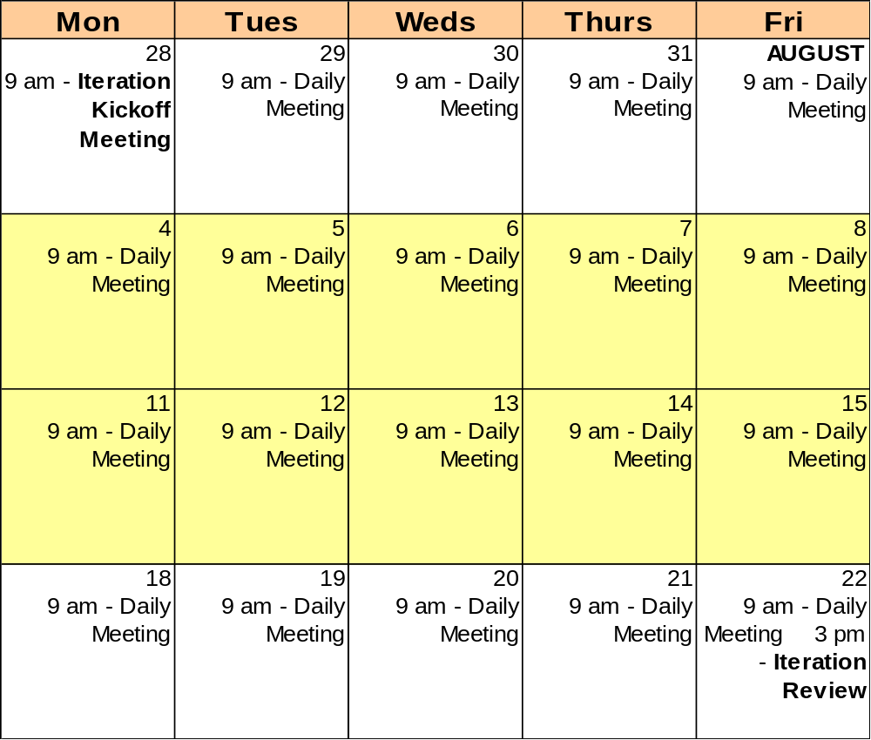

Sample Iteration Kickoff Agenda

Iteration Kickoff Meeting Agenda

Goals
- Gain common understanding of all features to be worked on during the current iteration, including feedback from the previous iteration
- Break features down into development tasks, provide enough information to estimate tasks, assign tasks to team members

Agenda
- Task Breakdown and Estimates
  - Remaining Tasks from Previous Iteration………………………..….. (30 minutes)
    - For each previous iteration feature not completed: Tier Leads
      - List remaining tasks
      - Estimate each task
  - New Business Features……………………………………………..... (30 minutes)
    - Overview of business features slated for current iteration Domain Experts
    - For each new business feature: Tier Leads
      - Break down into tasks Developers
      - Estimate each task
  - New Technical Features…..…………………………………………. (30 minutes)
    - Overview of technical features slated for current iteration Technical Mgr
    - For each new technical feature: Tier Leads
      - Break down into tasks Developers
      - Estimate each task
- Feature Selection……..……………………………………………………….. (15 minutes)
  - From all estimated functionality, select appropriate amount Iteration Mgr
(Based on calculated team capacity) Project Owner
- Task Assignment…………………………………………………………........ (30 minutes)
  - Assign tasks Tier Leads

Packet Contents (for each meeting participant)

- Previous iteration task list current with updated feature/task status
- List of new features slated for current increment
- New business features documentation
  - Existing requirements documents
  - Test scripts
- New technical features documentation
  - Existing requirements documents
  - Test scripts
- Team list and calendar

Sample Project Feature List

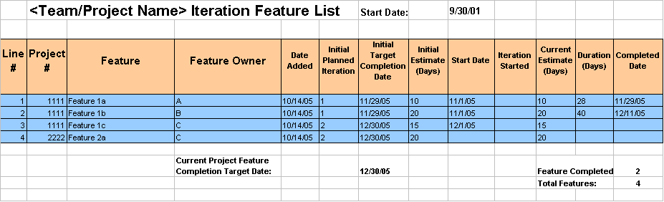

Sample Iteration Task List
The first page of the iteration task list spreadsheet contains the basic data about iteration tasks by feature.

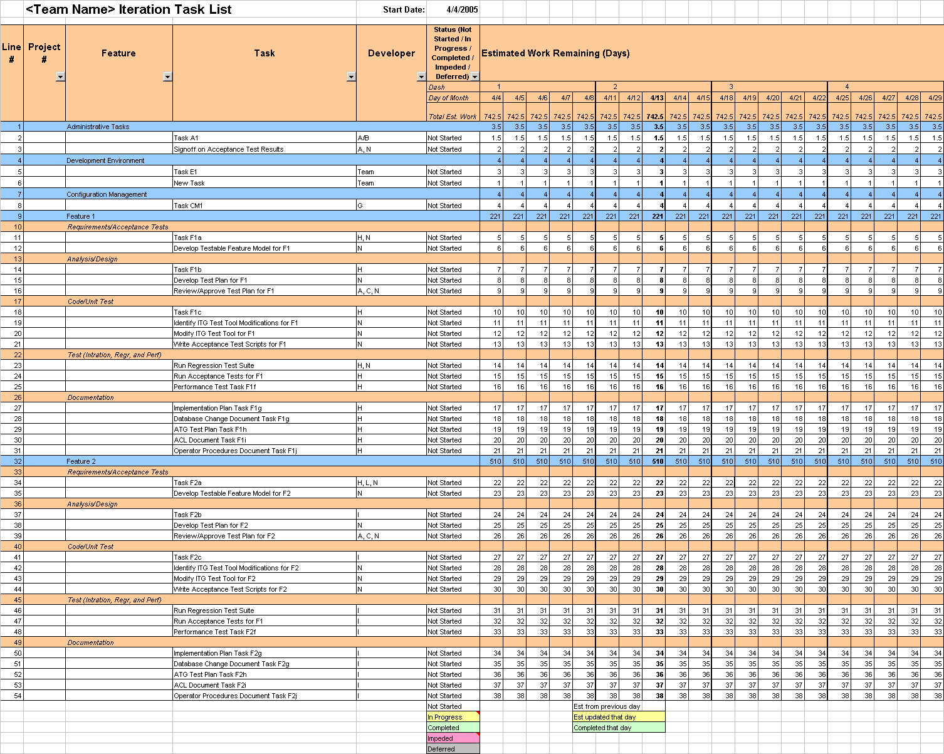

The data from the iteration task list is charted on a burn-down graph to visually show iteration progress.

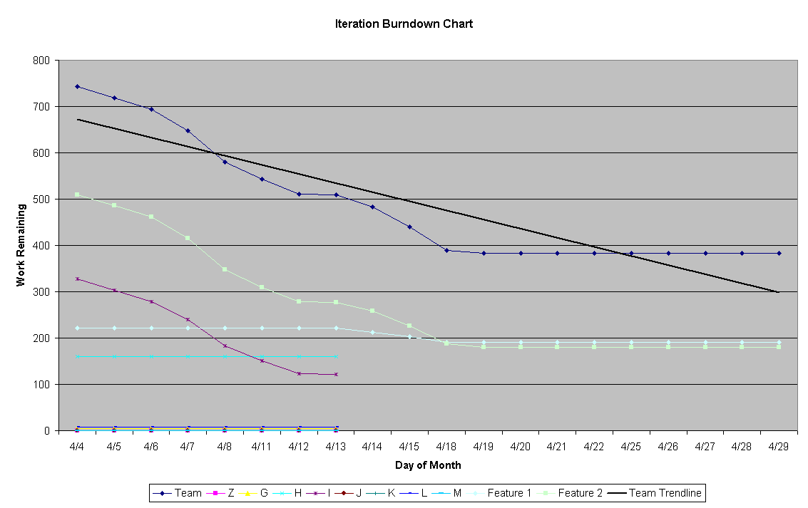

Sample Issue / Impediment List
The issue / impediment list is a page in the iteration task list workbook.

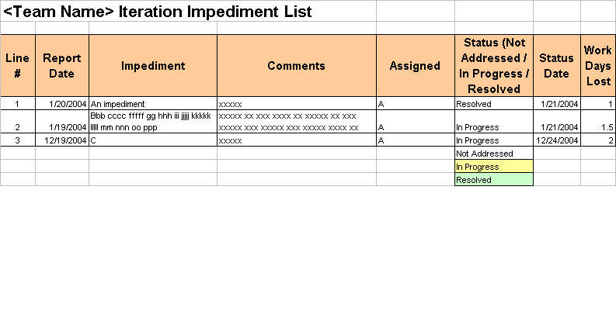

Sample Acceptance Test Case
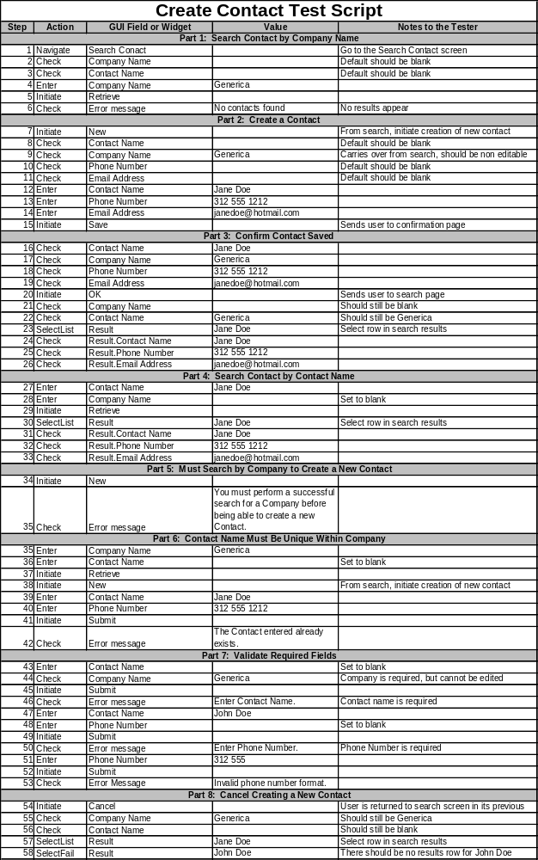

Sample Prioritized Feature List
Include a formatted picture of sample feature list.

Additional CBOE Artifacts
Add examples of the following additional artifacts

Project Charter

Application Architecture Document

Requirements/Use Case Document

Project Checklist

IDL Changes Document

DB Changes Document

Design Documents and Models (UML)

Data Model (Logical)

Database Build (DDL)

Data Definitions Document

Test Plan

Operator Procedures

Rollout / Implementation Plan

Configuration Document

